Renewable Energy Project
Preliminary Report

Michael Horn
Garrett Cornelius
Nicholis Santana
Issac Granados
SPRING-FALL 2023


Northern Arizona University
Department of Mechanical Engineering

Project Sponsor: Steve Wineicki
Faculty Advisor: Dr. Carson Pete

DISCLAIMER
This report was prepared by students as part of a university course requirement. While considerable effort has been put into the project, it is not the work of licensed engineers and has not undergone the extensive verification that is common in the profession. The information, data, conclusions, and content of this report should not be relied on or utilized without thorough, independent testing and verification. University faculty members may have been associated with this project as advisors, sponsors, or course instructors, but as such they are not responsible for the accuracy of results or conclusions.

TABLE OF CONTENTS

DISCLAIMER 1
1. Background 4
1.1. Introduction 4
1.2. Project Description 4
1.3.2. Original System Operation 5
1.3.3. Original System Performance 5
1.3.4. Original System Deficiencies 5
2. Requirements 6
2.1. Customer Requirements 6
2.2. Engineering Requirements 7
2.3. House of Quality 8
3. Design Space Research 8
3.1. Literature Review 9
3.1.1. Energy Modeling Review 9
3.1.2. Financial Review 10
3.1.3. System and Subsystem Review 12
3.2. Benchmarking 14
3.2.1. System Level Benchmarking 14
3.2.1.1. Ground Mounted Solar Design 15
3.2.1.2. Roof Solar Design 16
3.2.1.3. Community Solar Farms 16
3.2.2. Subsystem Level Benchmarking - Nick/ Michael 17
3.2.2.1. Panels 17
3.2.2.1.1. Monocrystalline: Most Efficient 17
3.2.2.1.2. Polycrystalline: Most Affordable 17
3.2.2.2 Batteries 17
3.2.2.2.1 Lead-Acid 17
3.2.2.2.2. Lithium Ion 17
3.2.2.3 Mounting systems 18
3.2.2.3.1. Fixed Ground Mounts 18
3.2.2.3.2. Pole Mounts 18
3.3. Functional Decomposition - Nick/ Garrett 18
3.3.1. Black Box Model 18
3.3.2. Functional Model / Work-Process Diagram 19
4. Concept Generation 20
4.1. Full System Concepts 21
4.1.1. Full System Design 1 - Original System 21
4.1.2. Full System Design 2 - Highest Cost Efficiency 21
4.1.3. Full System Design 3 - Highest Capacity 22
4.2. Subsystem Concepts 22
4.2.1. Subsystem 1 - Panel Type 22
4.2.1.1 Design 1 - Q.Peak 365 22
4.2.1.2. Design 2 - Trina Tallmax TSM-DE15V(ii) 23
4.2.2. Subsystem 2 - Battery Storage 23
4.2.2.1. Design 1 - Big Battery Kong Elite - 19kWh 23
4.2.2.2. Design 2 - Mammoth Pro - 23.5kWh 23
4.2.3. Subsystem 3 - Tilt Angle 24
4.2.3.1 Design 1 - Fixed Tilt Angle 24
4.2.3.2 Design 2 - Automatic Variable Tilt 24
5. Designs Selected 25
5.1. Technical Selection Criteria 25
5.2. Selected Designs and Justification 25
6. References 27
7. Appendices 28
Appendix I: Original System Spec Sheets 28
Appendix III: Original System PVWatts Report 33
Appendix IV: Original System Quotes 34
Appendix V: Renewable Energy Systems Pugh Chart 36
Appendix VI: Back-of-the-Envelope Calculations 36
Appendix VII: Black Box Model 37
Appendix VIII: Work Process Chain Diagram 37
Appendix IX: House of Quality 38

1. Background

1.1. Introduction
This document is a preliminary report detailing the initial stages of the Renewable Energy Project. The processes of problem identification, determining customer and engineering requirements, literary research, system benchmarking, concept generation, and final design selection are included within this document. This document is a critical step in an expansive and detailed project, which will involve several more intermediary stages and deliverables. Technical analysis to include energy modeling, structural analysis, wind projections, and load analysis will be the next initial steps, following a formal presentation of this report. Prototyping, testing, material procurement, and construction will follow within the final stages of the project.

1.2. Project Description
The stakeholder and client, Mr. Steve Winiecki, will be constructing an off-grid cabin in Camp Verde, Az. This cabin will act as a permanent residence for him and his family. Construction plans are already completed, however power generation has not been acquired. It is the Renewable Energy Team’s responsibility to design and oversee the implementation of a power generation system; this system will consist of a solar photovoltaic (PV) system. The customer and engineering requirements are detailed below in section 2. Requirements.

1.3. Original System
This project is based on work previously completed by a group of ME 451 Renewable Energy students. The completed work includes a final report, consisting of a site layout, bill of materials, and warranty information. Previously completed HVAC and construction plans for the cabin are available to the team, which include engineering drawings and descriptions. Information about the thermal properties of the cabin is not provided, however information regarding the HVAC loads is present. A zip folder containing datasheets for many components is also provided. These data sheets may be located in Appendix I.

1.3.1. Original System Structure
One of the customer requirements is for the system to be capable of utilizing power from the grid, and power generated by the PV system. The client specifically requested that the system is capable of eliminating any feedback into the grid, during times of excess PV power generation. In order to achieve this, a specialized inverter is necessary. The FLEXpower Radian GS8048-A-01 is equipped with programmed settings which prevent feedback for grid tied systems, while still allowing the user to draw from the grid. Although no electrical diagrams of the system are provided by the previous team, the system structure will be based on the needs and configuration of this inverter. A basic diagram depicting the most simple configuration for this inverter is shown in Figure 1.

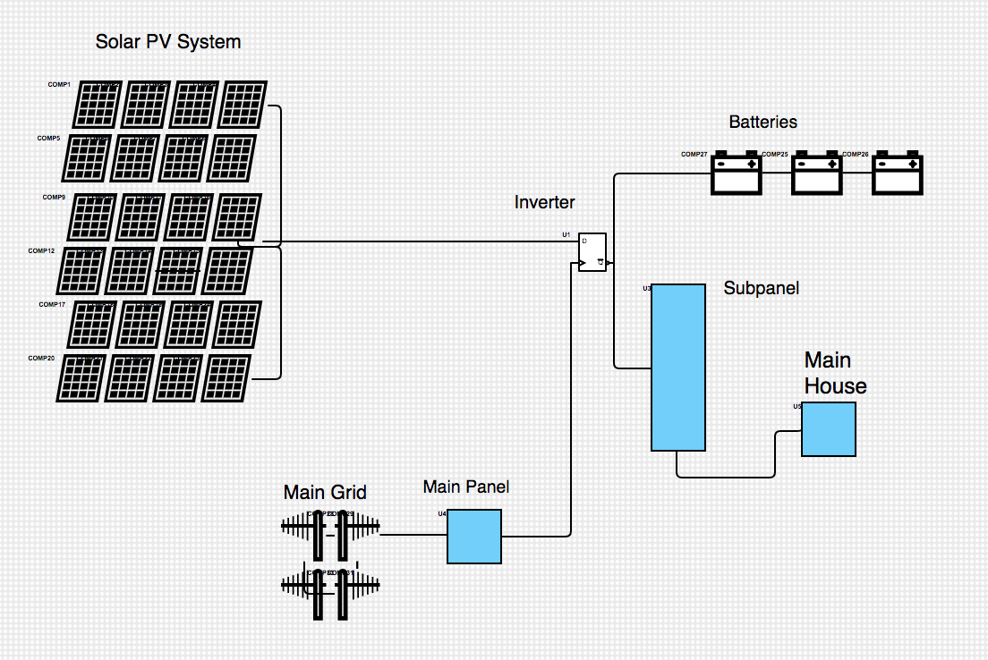
Figure 1: Basic Electrical Diagram for FLEXpower Radian A

1.3.2. Original System Operation
The original system operates using a specialized inverter, known as the Outback Radian A series. This inverter is equipped with “GridZero” mode, which enables the user to draw power from both the grid and an additional AC power source, without backfeeding into the grid. This system would utilize a fixed tilt angle, ground mounted solar array, equipped with Q.Peak Duo BLK 365 solar panels. A complete bill of materials for this system is located in Appendix II.

1.3.3. Original System Performance
Using the National Renewable Energy Laboratories online PVWatts calculator, this system can be estimated to produce about 15,099 kWh/ year of energy. A summary of this calculation can be found in Appendix III.

1.3.4. Original System Deficiencies
The most prioritized deficiency of this system is the cost. As well as technical documents, two quotes from solar companies are provided by the previous team students, which can be accessed in Appendix IV. These quotes far exceed the client’s budget, preventing the project from completion. The current team is invested in procuring the most economically efficient materials possible, while retaining adequate quality.

2. Requirements
The initial proposal that comes from the client gives the team a foundational groundwork requirements to build off of. Once the evaluation of these requirements are finalized, the team then sets up their own criteria of how each requirement will be met. Each requirement will have its own value of importance and determining how to move from there will be discussed within a later section of this document.

2.1. Customer Requirements
Upon speaking with the customer, a few key elements were communicated right away. Our grade scale is on a 1-5 point scale, 1 being the least of customer concerns and 5 being the highest. Down below is the team's customer requirements with its scale value attached.
* Cost Efficient - 3
* Large Storage System - 4
* Reliable/Adaptable Design - 4
* Solar Generation Heavy - 5
* Safe to operate - 5
Having a cost efficient system is scaled at a midpoint value based on our customer’s requests in the way that he wants to set up his system. As he understands that the cost of the system will be expensive he has given the team a range of costs that he would be willing to spend compared to the cost that he is hoping to spend.
The team’s client is hoping to create an off-grid system which would rely solely on the solar generators that would create electricity throughout his house. He will need to have an adequate store system capable of retaining some of that power for later use when the sun isn’t present. Since he will be having the option to take power from the grid in the event of an emergency his storage system isn’t one of the highest requirements.
Although the client’s house will run from an off-grid system, the option of taking power from the grid will be put in place just in case of emergencies. However, since the client is going to do what he can to not rely on the grid, this requirement isn’t placed on the highest scale level.
With any off-grid system, the energy being produced from outside sources is the top priority of that system. The team’s client wants the option of a full off-grid system which means the solar generation that will be generated daily will be one of the main priorities for the client and the team.
Within every engineering field having a safe, reliable and adaptable system is essential for any product being made. The team also has to take into consideration the laws and regulations of the area that this solar system is being built on so that the grid tied company that the client will be connected with, won’t deconstruct the system and reconstruct it back to code.

2.2. Engineering Requirements

As the team evaluated the Customer Requirements, the same amount of engineering requirements are in place as shown below. With each requirement that is shown, not all requirements have a positive impact on the others. Each requirement is listed below along with its targeted requirements as well as the tolerances.
* Decrease Design Cost $35,000 $-$10,000
* Increase Efficiency 2.99 $/W$\frac{+}{-}$.5
* Increasing Generation 30 kWh/month $\frac{+}{-}$3
* Increase Storage 15 kWh $+$5
* Increase Adaptability 3 units +2
With the budget for this project having a varying range, the team has decided to aim for the smallest amount of cost for the client with an understanding that certain items may be more expensive based on the quality of products, failed tests, and degradation of the system overtime. In order for the team to minimize the cost of the design, looking at a long term timeline and understanding the replacement costs are taken into account. The targeted value for the cost is around 35,000 dollars with a negative 10,000 dollars if possible.
The house itself also holds a role in the way that energy is saved. The installation process of the house will be a determining factor of the amount of energy needing to be produced on a daily basis. If the installation process has high marks, the energy that is being produced will be able to be more efficient in other areas of the house and vice versa if the process is poor. Another factor that can play a part within the efficiency would be the angle of tilt of the solar panels. The targeted value for the efficiency is 2.99 dollars per Watts with a positive or negative 0.5 tolerance.
The positioning of the solar panels does determine how much generation of electricity will be produced. By understanding the best angle to place a solar panel throughout the year will give the user the most generation from the system. The type of panels used within the system also plays a part when taking into account the losses of that generation process. The targeted value for the energy generation is 30 kilo-Watt-hours per month with a tolerance of positive or negative 3.
As the client doesn’t want to rely on the grid, a battery system is a needed aspect within the project. Being able to utilize the extra generation of the solar panels at a later time is very beneficial to the client when the sun sets and he will be reliant on that leftover energy until the panels generate more power the following day. In many instances having a backup storage unit of a minimum of 3 day usage is recommended for any off grid system. With that in mind, the team needs to locate the best quality, at a reasonable cost, battery storage unit that will give its user a 3 day lifespan if no generation from the solar panels are being produced. The targeted value for energy storage is 15 kilo-watt-hours with a positive 5 tolerance.
With a hybrid system the components of incorporating the electrical company and their policies will be followed to a degree. Since the client doesn’t want to back feed his solar generation to the grid the safety measures for the electric company isn’t as big of a problem since power will not be constantly going to and from the house. If the electric company, for whatever reason, needs to shut off the power being provided to its clients, the team’s client will not be affected by the shut off switch and would still be able to use his own power that has been generated with the solar panels. The targeted value for the amount of sources of energy being directed to the house is 3 with a tolerance of positive 1.

2.3. House of Quality
Taking the information from above, the team constructed a House of Quality document that states the importance of what the customer is asking for along with the improvements that the team can provide. As stated above the Customer’s Requirements and the Engineering Requirements with their targeted values are as follows:

- Cost Efficient 3 1. Decrease Design Cost $35,000
- Large Storage System 4 2. Increase Storage 2.99 $/W
- Safe to Operate 5 3. Increase Safety 30 kWh/month
- Solar Generation Heavy 5 4. Increase Generation 15 kWh
- Reliable/Adaptable Design 4 5. Increase Efficiency 3 units

3. Design Space Research

A major factor in engineering and design is the exploration of existing work that relates to the project. Oftentimes, engineering and design builds off of the work and science that have already been completed. Quality research allows the team to dive deeper into standardized practices, existing solutions, and cutting edge designs. The ultimate goal of design space research is to create the best possible product that meets the client’s requirements.
Mr. Winiecki, for example, is looking to make a sizable investment in his off-grid system. He is very budget minded and requires a quality system that he can depend on for decades to come. Following our customer’s needs, our team has decided to base our research and benchmarking on topics that will allow us to offer the most viable options to our customer. This process begins with an in-depth literature review of articles and research regarding topics of finances, modeling programs, and existing systems. Furthermore, our team has identified multiple other systems and subsystems that we can use to benchmark our designs from.

3.1. Literature Review

Before designing a PV system, it is important to research comparable designs and find relevant data that can aid both the development and selection of a design. Our team focused on three main areas of research: Energy Modeling, Financials, and PV Systems. The main deliverable for the first semester of this project is to develop an accurate energy model that depicts the energy usage and heat losses of the home. With this being a pivotal part of the project, it was important that the team understands what energy modeling is, how it is used, and why it is relevant. The second area of research was regarding the financials of a PV system. Because our team is reliant on funding from the customer, it is imperative that our designs be cost effective and that our quotes take into account any applicable tax credits and incentives. Finally, the third section of the literature review covers existing and leading edge technologies within the PV system. By having three distinct research areas within the literature review our team will develop an encompassing competency around the PV design. The result should be a design that will meet and exceed all engineering and customer requirements.

3.1.1. Energy Modeling Review
The following sources all relate to energy modeling. As the main deliverable for the first semester, it is important that the team develops a strong foundational knowledge of what energy modeling is, how it is used, and how we can apply it to our project. CAD Design Lead Garrett Cornelius, will be taking on the majority of the research and apply his findings and knowledge during the creation and development of the cabin energy model.

- https://www.energy.gov/eere/buildings/about-building-energy-modeling [1]
The Office of Energy and Efficiency & Renewable Energy is the forefront of information on how the United States Government utilizes building energy modeling (BEM) systems. This particular article explains what exactly BEM systems are and how they work. The useful information in this article is how construction projects can benefit from the use of BEM software.

- https://www.energy.gov/eere/buildings/articles/energyplus [2]
The second source of the team’s literature review is an article that was written by the office of energy efficiency and renewable energy in August of 2014. The main point of this article, as it pertains to this project, is that energy plus has received $83 million in funding to date. This program serves as a backbone to any energy modeling project that can/will be converted into a physical solar system. With the growing interest in renewable energy across the United States, this article discusses how the DOE (department of energy) is funding this energy plus project to help current and future renewable energy projects.

- https://www.energy.gov/eere/buildings/articles/building-energy-modeling-101-hvac-design-and-operation-use-case [3]

The third article from the The Office of Energy and Efficiency & Renewable Energy demonstrates BEM software’s application with respect to HVAC systems. The article also shares vital information on the application or “Real-Time Modeling”. Mr. Winecki will be running two mini split HVAC systems to cool his home in the summer and the information from this article will help the CAD team understand how to use adaptive weather based modeling systems. Understanding this should create a more accurate assessment of the electrical needs of the home.

- https://www.energy.gov/eere/buildings/articles/building-energy-modeling-101-inherent-performance-rating-use-case [4]

The fourth article is also from the Office of Energy and Efficiency & Renewable Energy. This article speaks to the performance of the building itself by defining an energy asset score. The author focuses on the optimization of the construction to attain higher levels of efficiency. Using BEM software, a user can compare materials, locations, appliances and more to define the greatest energy losses in the system. While our team will not be constructing the home, this knowledge can be applied when creating a baseline assessment of how energy efficient the home is before any material or electrical needs are in place.

- https://journals.sagepub.com/doi/10.1177/2399808319841909 [5]
The fifth source under Energy modeling is a 2019 journal written by Tarek Rakhand and Rawad El Kontar about the optimization of BEM to the real world. A major design challenge for the team is to develop a system that meets the energy needs of the home. Unfortunately, this creates a large problem when it comes to modeling according to the journal source. The issue stems from the differences in the energy uses of the resident. Some residents used less than modeled, and others used much more than modeled. The work also notes that modeling systems only estimate the usage for today’s appliances and does not take into account an increase in electrical usage over time. This source will give the design team insight on the idea of tailoring a system to our specific user and the financials of over and under-building a system.

3.1.2. Financial Review

Mr. Winecki is the sole funding source for this project. He is a retired firefighter and is looking for a system that will provide a great value and profitable return on investment over the life of the solar system. Our goal is to present Mr. Winiecki with a system that we believe is best suited for his financial and electrical needs. However, funding status can change for private clients and the team will need to be prepared to opt for a lower cost system. Understanding every aspect of the cost for a PV system is imperative. Team Lead Michael Horn and Nicholis Santana have been delegated with the roles and responsibilities pertaining to the project and design budget. They will be working together to find, research, and apply the most cost effective solutions to this project. The following sources are all in regards to funding, tax breaks, and return on investment for PV systems.

- https://www.electricitylocal.com/states/arizona/camp-verde/ [6]

Understanding a home’s energy needs is the first step in designing a PV system. Most solar companies utilize an existing energy bill to understand the average kW needed for the home. With a known KW draw, a system can be designed to meet those needs. For this project, the house is yet to be constructed and there are no energy bills to work from. This source identifies the average price per KWh for the Camp Verde Area. This data will be used to develop a return on investment and financial model for the budget team.

- https://www.iea.org/reports/clean-energy-innovation [7]

The International Energy Agency flagship report was completed in 2020. This source identifies the overall return on investment for PV systems worldwide. The report identifies that manufacturing and material improvements have brought the total costs of solar down dramatically with respect to time. The budget team will utilize this information during benchmarking to identify the differences in cost from a solar system completed 10 years ago to a system that was installed recently. With the cost of solar panels decreasing, the team will be able to demonstrate the capability of a larger system within the same budgetary constraints.

- https://www.usda.gov/sites/default/files/documents/renewable-energy-trends-2020.p df [8]

The USDA submitted a report regarding renewable energy trends. The report describes the decrease in capital costs of PV systems and other forms of renewable energy systems across the board. The article provides great financial and system data to support the benchmarking and budget aspects of the project. Another benefit of this source is the application of renewable energies in a real world environment and specifically agriculture.

- https://palmetto.com/learning-center/blog/everything-you-need-to-know-about-the-solar-tax-credit [9]

When quoting the price of multiple systems to our customer, any applicable tax credits can make a sizable difference in the scale and affordability of the system. This article speaks on the specifics of the Inflation Reduction Act which is a federal tax credit for residential solar systems. According to the article, up to 30 percent of a PV system's price can be written off as a rolling tax credit. Our design must meet all of the requirements to take full advantage of this program and will be used by both budget and design teams.

- https://azdor.gov/forms/tax-credits-forms/credit-solar-energy-credit [10]

Related to the source above, Arizona has its own tax credit program for privately owned residents. The article defines the requirements for the solar system as well as showing the possibility for a $1,000 Arizona tax credit. More importantly, this tax credit applies to the property value increase. Adding a forty thousand dollar system to a property can raise property taxes over the life of the system. This is an aspect that the budget team will need to account for when creating a return on investment report for the project.

- https://www.solarpanelstore.com/blogs/solar-panel-store-blog/solar-home-grid-tie-system-sizing-part-1-using-a-utility-bill [11]

This source is a simple step by step procedure on how to find your home’s energy use and how it could be improved by solar polar. The article shows a 4 step process that will show the user what solar system might be a good fit for their circumstance. This source was used as a starting point for the group when designing a solar system. This source also serves as a way to estimate how much energy could be transferred to solar by a given system. Thus reducing a percentage of a monthly energy bill.

3.1.3. System and Subsystem Review

The sources below all relate to the PV system or a subcomponent of a PV system. Research into this area allows the team to have a better understanding of existing technologies and designs. The team’s test engineer Issac Granados will be utilizing most of these sources to become an expert in various designs and components. This will allow him to create a test methodology that the team can use to compare and benchmark our design. The team as a whole will also be conducting research to develop concepts and understand the advantages and differences between a multitude of existing designs and systems.

- https://www.forbes.com/home-improvement/solar/most-efficient-solar-panels/ [12]

This article is directly related to the design of our panels in this project. This source describes the top of the line panels and the most affordable models. This will directly impact our design of our solar panels. The goal is to be as close to efficiency of the top of the line models whilst still maintaining the cost efficiency of the most affordable models. This article was directly used in the benchmarking of our panel design.

- https://www.forbes.com/home-improvement/solar/what-is-a-solar-battery/ [13]

An engineering requirement for this project is to have some degree of battery storage. Electrical storage can easily become one of the most cost prohibitive components of the system. This article speaks on the usage scenarios as well as various forms of battery technologies that are applicable to this scenario. With cost, life-cycle, and capacity being a major factor in concept selection, understanding the entirety of battery technology and its drawbacks is imperative.

- https://www.forbes.com/home-improvement/solar/ground-mounted-solar-panels [14]
Due to the location of the cabin, a ground mounted solar panel system is looking to be the most applicable. To understand the advantages and disadvantages of a ground mounted system, the team will be using this article from Forbes. The author claims that ground mounted systems can be more versatile and efficient compared to roof mounted designs and have no apparent drawbacks. This article and its sources will provide viable justification in the selection process to go with a ground system.

- https://www.solar.com/learn/micro-inverter-string-inverter-comparison-solar-equipment/ [15]

The article above, written in 2022, compares traditional string inverters with a newer technology of inner-panel micro inverters. While micro inverter panels are more costly, the article outlines several key advantages that microinverters have. The budget and design team must compare subcomponents to decide if the increase in capability, scaling, and installation advantages will outweigh the cost impact.

- https://www.solar-electric.com/learning-center/what-components-typically-used-off-grid-solar-power-system/ [16]

Researching efforts and designs within the project radius can lead to understanding the requirements and complications that specific areas present. This article was written by a company in Northern Arizona. It specifically speaks on off-grid applications and the components that are primarily used. Within the article, the author speaks on the importance of designing a system around the local environment. Our design team will need to do just that when taking into consideration weather and sun data for the PV system.

- https://unboundsolar.com/blog/best-solar-panel-mounts [17]

This source will be used directly for our 3 sub system benchmarking. This article goes over the different types of mounting systems for solar systems. This article shows not only options for roof mounted systems but also for ground mounted systems. Our design will be a ground mounted system. With this source, the team will be able to compare our design to various different designs.

- https://s3.amazonaws.com/zcom-media/sites/a0i0h00000KyCXiAAN/media/mediamanager/OutBack_Radian_4048A_8048A_Inverter_manual.pdf [18]

A string inverter is one of the most fundamental subcomponents of a PV system. The following pdf is a manual of an inverter made by Outback Power. This type of information is extremely valuable because it shows the capacities of this particular inverter. Understanding manufacturer specifications is paramount for both safety and design. This manual also demonstrates the proper wiring layout when installing. Manuals such as this will be used by the design and install team throughout the second half of the project.

- https://www.outbackpower.com/downloads/documents/appnotes/gridzero_app_note.pdf [19]

This PDF published by Outback Power is an application note for one of the company's premier PV system controllers. A controller similar to the one cited will be used by our team to manage the entire system. Outback’s GridZero mode enables a renewable energy system owner to maximize the use of their generated electricity and minimize energy purchased from the utility by fully utilizing energy storage. This documentation will aid the team during the design and procurement process by showing what is capable with off-the-shelf components.

- https://www.solarreviews.com/blog/what-are-solar-inverters[20]

This article is a buyer's guide to inverters. The article outlines the different types of inverters of a solar system and the associated pros and cons. An inverter in our design will be the “middle man” between our solar panels and the clients house. The inverter of our design will be treated as a sub system. The team will use this article as a starting point when designing and choosing an inverter for the project.

3.2. Benchmarking
Benchmarking is a pivotal step for our team’s design process. While this project does not rely on reverse engineering or groundbreaking research, it is still important to compare our design to existing applications. Benchmarking reveals relevant problems and gives insight on how other engineers have developed solutions. To be thorough, our team will be conducting online research and comparison into a system-wide solution as well as diving into individual components and subsystems. Invaluable information can be gathered from current designs and component selection decisions. The following sections will discuss system and component level benchmarking tactics.

3.2.1. System Level Benchmarking
With regards to photovoltaic systems, there are countless mounting styles, panel arrangements, system scales, and applications. To narrow this field of view for benchmarking that will be most impactful to our system, this will be narrowed into mounting arrangement and scale of the system. This level of benchmarking will be comparing several system layouts and locations to find the advantages and disadvantages of each.

3.2.1.1. Ground Mounted Solar Design
A singular ground mounted system has more advantages than a roof solar system. Having the ability to direct panels to the best possible angle for consumption, choosing the area of least obstruction, and creating a higher return on investment are the main advantages. There are two different types of systems, Standard and Pole Mounted. Each of these systems have their own advantages and disadvantages compared to one another. Below describes the differences between the two systems.
- Standard Ground Mount
  - Low to the ground surface,
  - Large surface area from its own metal frame that has a fixed angle towards the sun
  - Option of being mounted above the surface
  - Simple installation and maintenance aspect
  - Doesn't work as well under snow conditions
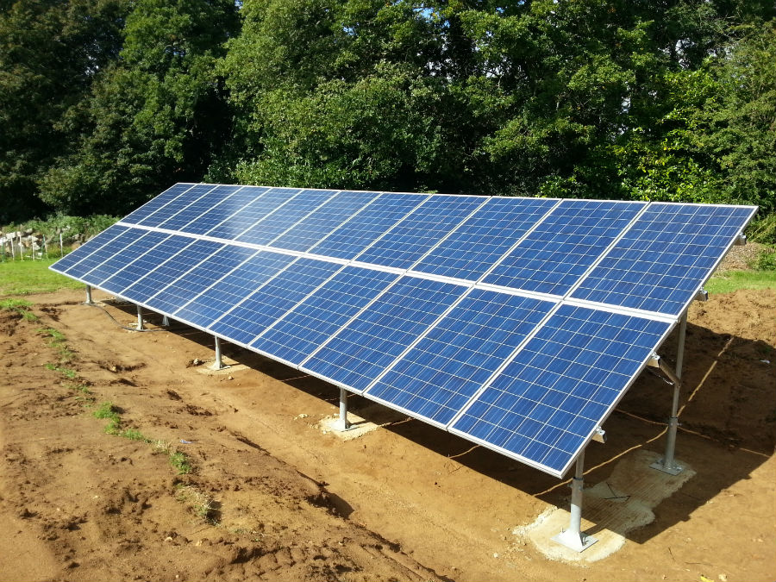
Figure 2: Standard Ground Mounted Solar Panels
- Pole Mount
  - Higher off the ground
  - Varies in surface area with its additional height
  - Capable of both a fixed or tracking system that follows the sun
  - Only option is to be mounted within the surface
  - High maintenance
  - Cost is higher
  - Electricity is needed to support the tracking system
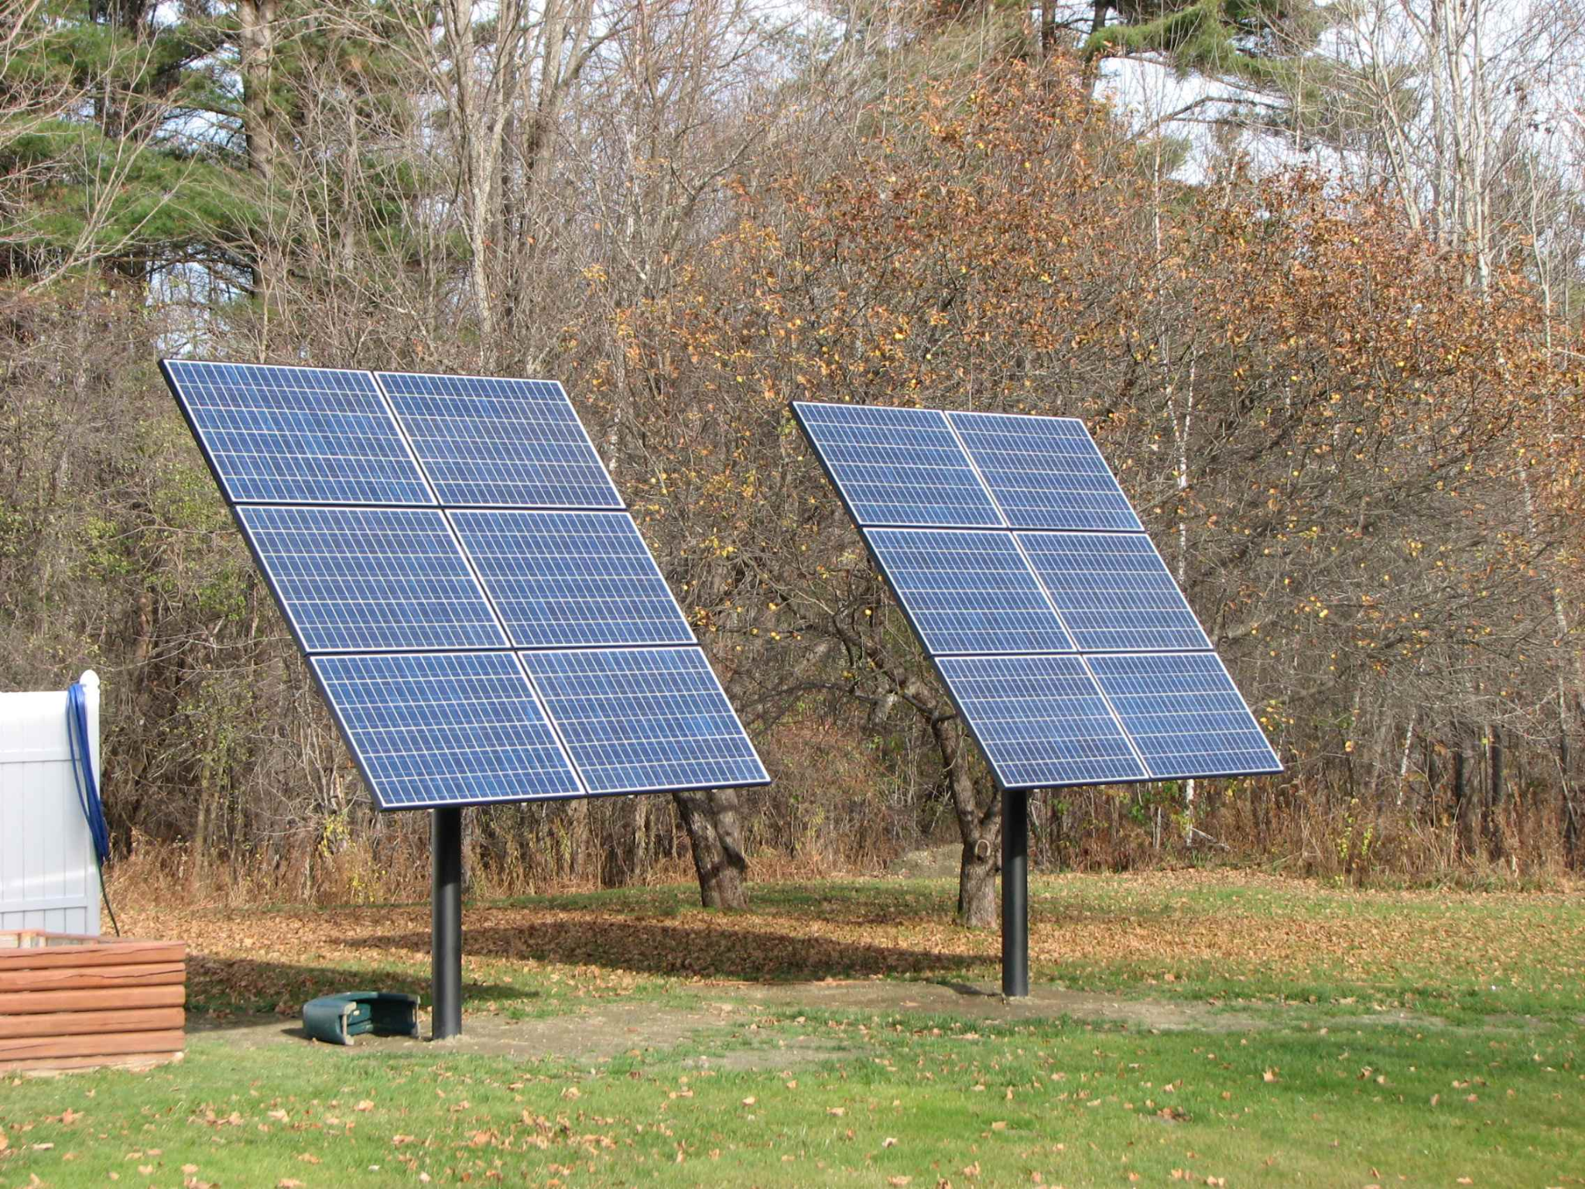
Figure 3: Pole Ground Mounted Solar Panels

3.2.1.2. Roof Solar Design
The first type of solar design started on the roofs of an individual home. These houses had limited space based on the size of the roof. This simple construction only allowed homeowners with a small reduction cost within their electricity bills based on the roof’s tile for the panels to be placed on. Since then, the panel designs have improved from laying panels directly on the roof to having a stand that raises the panel above the roof's surface. It was discovered that the hotter the panels get, the greater the losses of energy generated. Now panels are lifted to create a channel of airflow underneath each panel to cool down the system to produce as much electricity as possible. There are still designs being tested/perfected when it comes to angle of tilt of the panels on roofs however most people use the original angle that their roofs already have and don’t get the full energy generation as they were expecting.
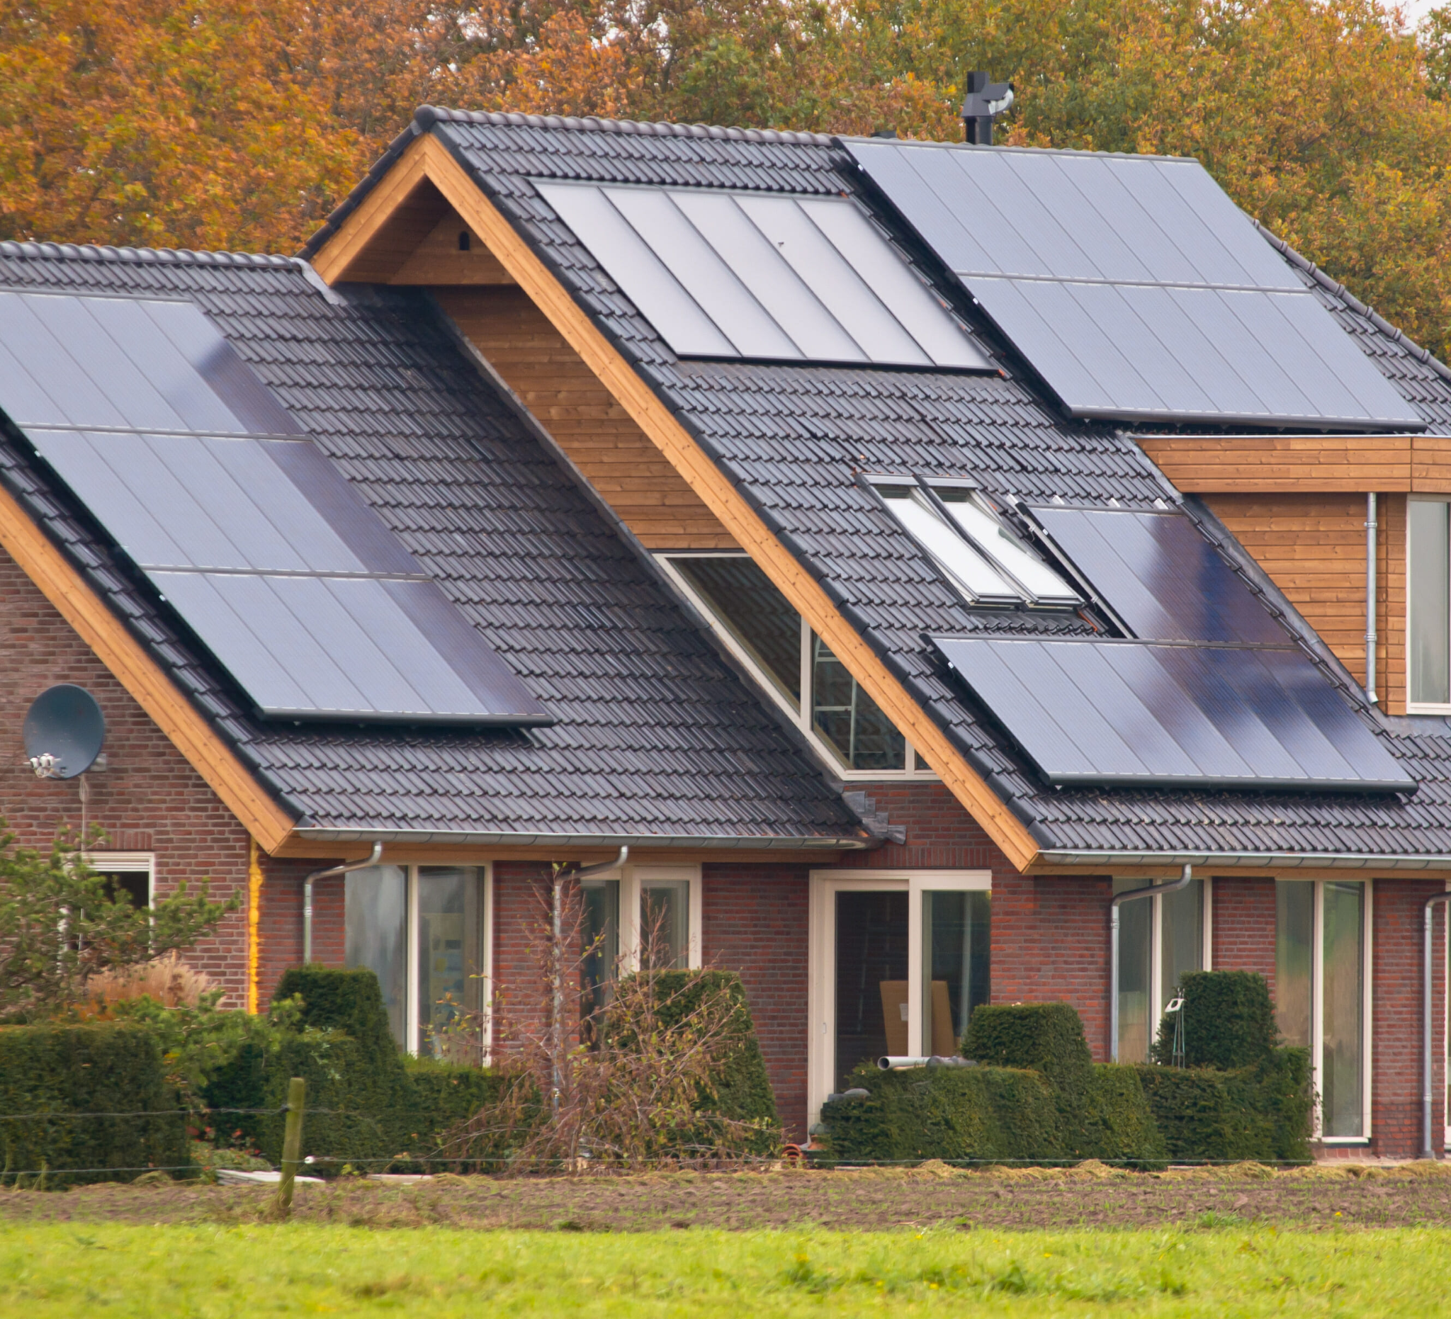
Figure 4: Solar Panels on the roof

3.2.1.3. Community Solar Farms
Solar Farms are community based solar systems that affect the lives of more than one home. These farms are all ground mounted systems that vary from fixed to solar tracking systems dependent on the company, budget, and average energy needed for the community. Most of these farms have slowly been integrated within larger electric companies to lower their carbon footprint by using this simple renewable energy system. Larger companies and organizations also use solar farms to produce their own energy for their buildings to reduce the cost of electricity and sell electricity to the electric companies to generate a small profit. Typically the owners of solar farms charge more if not the same cost as the electric companies.
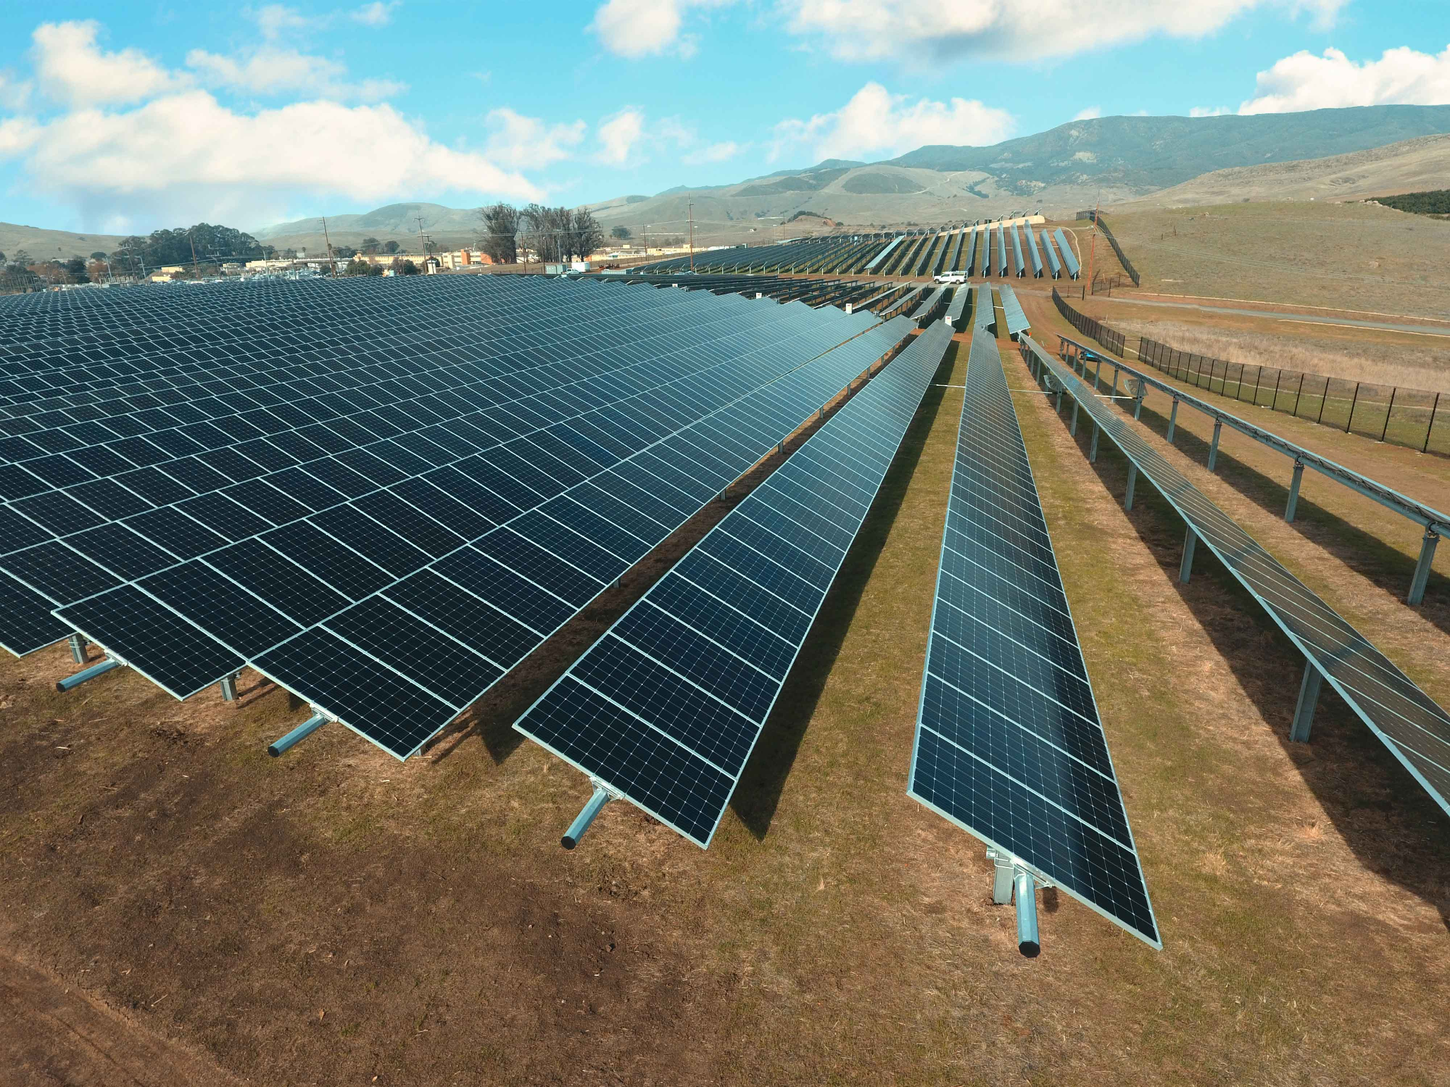
Figure 5: Solar Farm within California used by the local college

3.2.2. Subsystem Level Benchmarking - Nick/ Michael
Subsystem level benchmarking allows the team to compare existing components of a solar PV system. Within this section, different devices of the same category will be determined and compared. This important step provides valuable insight on different existing designs for achieving similar functions.

3.2.2.1. Panels
The solar panels are a component of our system that innaties the transfer of solar energy into free electrons. This is the catalyst for our whole system. With the development of solar panels over the years it is crucial for our design to be on par with the current models. Our design needs to include solar panels that are as efficient as existing designs/products.

3.2.2.1.1. Monocrystalline: Most Efficient
Monocrystalline panels are the most efficient panels on the market. The only thing that makes this design non useable is the price point. These panels are far out of budget for most commercial projects and thus will be far out of our budget. However these panels have an efficiency of 15 to 22 over a 25 year life span. Some of our requirements include cost efficiency and solar generation. This existing design is at the high end of both. Our goal is to be comparable to this panel’s efficiency whilst being more cost effective.

3.2.2.1.2. Polycrystalline: Most Affordable
Polycrystalline panels are a more realistic option for our design. They are more commonly used in solar systems. They provide an efficiency between 13% and 17%. This is below the efficiency of the monocrystalline, but still a viable option. Because most affordable systems are between 13% and 17% efficient, this will serve as an efficiency benchmark for our panel design. Ideally, our design would top this efficiency whilst still being as cost effective.

3.2.2.2 Batteries
The batteries are the component of our system that will store power and energy for future use. Once energy has been transferred from the panels into free electrons, it can be used in the house or be stored. If there is no use for the free electrons/energy at the moment it's converted, then the batteries will be what holds the energy for future output.

3.2.2.2.1 Lead-Acid
Lead acid batteries are more commonly used by homeowners in solar systems. This is because they are one of the most affordable options. Recent technology has made these types of batteries more viable and effective. Lead-acid batteries will serve as a minimum benchmark for our project. Because one of our client requirements is to be cost effective, this type of battery will be a viable and realistic option.

3.2.2.2.2. Lithium Ion
Lithium ion batteries are a newer option. Lithium-ion batteries have a high energy density and offer a smaller, lighter and more efficient option. The only con with this type of battery is the cost associated with it. This type is very much more expensive than the Lead-acid alternative. Because of this, Lithium ion batteries may not be a realistic option for our design and client. However the energy density and efficiency of lithium ion batteries will serve as a high end bench mark for our time. The goal will be to strive for as close to the performance of Lithium ion while reducing the cost as much as possible to fit the clients budget.

3.2.2.3 Mounting systems
A mounting system is the structural support of a solar system. The team will use a mounting system in our design to keep us in place. On the project grounds, the mounting system will also serve as a way to protect the system from the wind forces. It is imperative that our design includes a robust mounting system to ensure there are no system failures. The two current designs that the team will benchmark with are Fixed Ground Mounts and Pole Mounts.

3.2.2.3.1. Fixed Ground Mounts
The first existing design that the team will use for benchmarking mounting systems will be a fixed ground mounted system. This system is just a simple metal frame to attach the panels to with footings to structurally support the system. As previously mentioned, this system is simple and will serve as a minimum requirement for the team's design. The one con with this system is the fact that it is not adjustable. This is something the team will look into improving when coming up with the final design.

3.2.2.3.2. Pole Mounts
Pole Mounts will serve as a goal for the team to strive for. These mounts are usually adjustable and have enough clearance from the ground to protect the panels. Pole mounts are also a way to protect the panels from heavy rain and snow falls. These mounts will serve as a goal for the team to achieve.

3.3. Functional Decomposition - Nick/ Garrett

The purpose of the functional decomposition is to break the entire design challenge into small-scale solutions. Decomposing and dissecting the design increases clarity on the engineering requirements and goals to outline a baseline functionality of the design and highlight interactions between subsystems. A hybrid PV system and its subsystems combine to create a complex network of energy and signal flows. To simplify the design, the team has employed two levels of functional decomposition: a black box model and a function chain diagram. The black box model is the most simplified decomposition as it focuses directly on the inputs and outputs of the system. It demonstrates that the design ultimately transfers energy from one location to another. The function chain diagram elevates the level of detail by creating a map of signal and energy flows between the subsystems within the design.

3.3.1. Black Box Model

The black box model depicted below in Figure 2 (Appendix VII) shows the appropriate inputs and outputs for our overall solar system. There are no physical material inputs or outputs for our system. Our system is based on energy and signal inputs and outputs only. The main inputs and outputs for our system are energy. For a renewable energy solar system, solar energy is the dominant input and source. As shown above, the dominant input of the system is solar photons. The Solar photon input then directly outputs to either battery electrons or an AC to power the house.

The grid electrons are also an input to our system. Once the solar energy has been transferred into energy, the grid can input this energy to output AC loads to the house. The AC loads are the exact desired output of the overall system.This output will ultimately be the desired output and use that the client requires from the system .

The final input to the system is an AC/DC signal. This is the only signal input for our system and the only non energy input for our system. This signal comes from any signal in the clients house (ex. A light switch). This signal input will be the catalyst that starts the energy transfer from the grid to the house. Because the house is the final destination for the power, there is no output signal in our system.
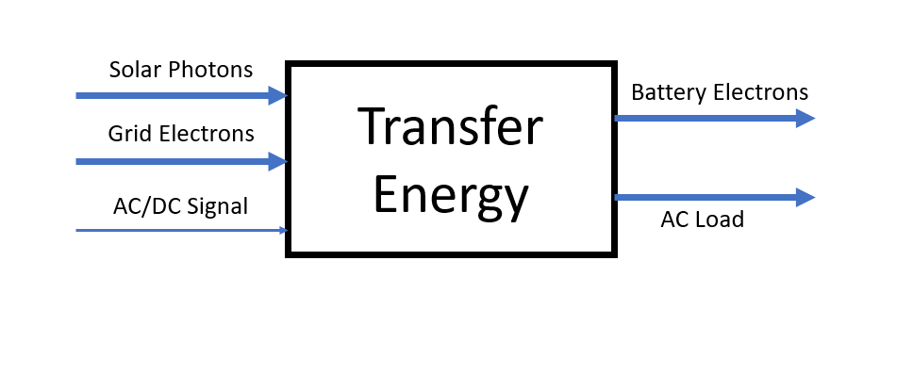
Figure 6: Black Box Model

3.3.2. Functional Model / Work-Process Diagram

A functional model is used to loosely define the overall process that the device will be subjected to during normal operation. It is designed to show the flow of inputs, outputs, and operations between subsystems and components so the team can have a simplified view on what the design is accomplishing at any given point. This simplification allows the team to be more effective and creative when implementing and designing small-scale solutions between each step.
The benefit of having a hybrid PV system comes from the varying forms of energy that can be used to power the home. However, it adds a layer of difficulty because the system needs to be self sufficient at managing these power inflows and directing the most efficient method into the home. This decomposition also includes several subsystems such as the panels, storage bank, and battery controller. Below in Figure 3 (Appendix VIII) is a functional chain that describes the process of the hybrid PV system and how the system will need to manage the flow of electricity. The chain’s arrows depict the flow of electricity and the dashed lines depict a signal transfer. This diagram demonstrates the flow of energy once a load is detected by the system and the multitude of paths that the electricity can take depending on the originating signal. In our system, the start of the transfer of electricity is signaled by an electrical need from the house. It is then up to the system and battery controller to determine the source of the power needed. The electricity could be sourced from the panels, the battery storage bank, or the grid depending on the states of each source. For example, if the sun has set and the panels are not generating any power, then the controller will source the power from the battery bank. However, If the battery bank is depleted then the system will source the needed electricity using grid power as a last resort.

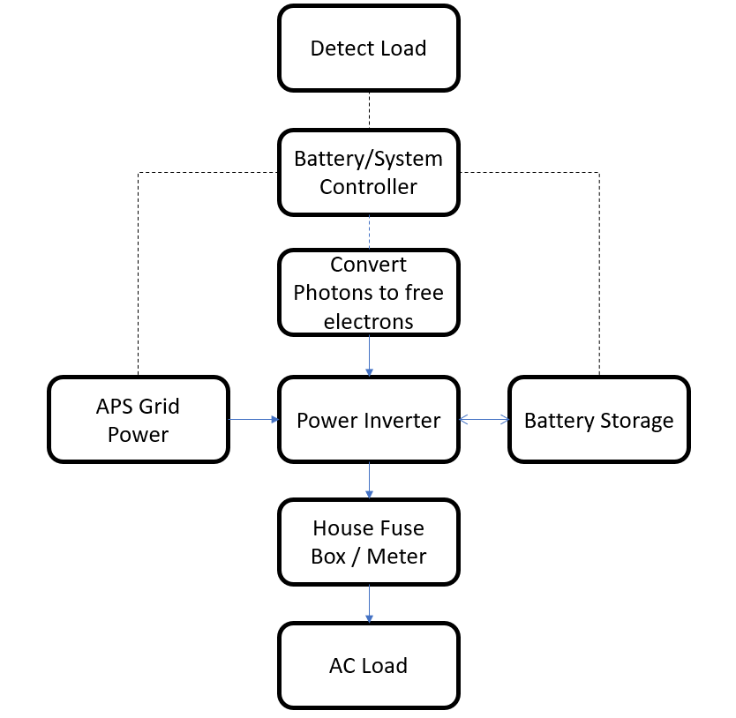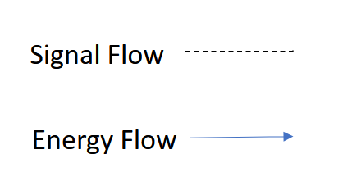

Figure 7: Work Process Chain Diagram

4. Concept Generation
In order to adequately determine an appropriate solution for the project, the team must engage in concept generation. Within this section it is described how the team effectively and concisely determined an appropriate design. Full system concepts and subsystem concepts are analyzed using decision enabling tools, such as a Pugh chart and decision matrix, in order to fully determine adequate solutions. These concepts are detailed below.

4.1. Full System Concepts

This comparison highlights the attributes and disadvantages of each design, allowing the team and client to qualitatively assess each design. Using a Pugh chart, these designs are compared to a datum, based on meeting the engineering requirements. This Pugh chart can be viewed in Appendix V. All of the following designs are for a hybrid solar PV system. Variations, such as alterations in components, are the driving force of difference among each design. Three full system concepts are listed below, with their corresponding pros and cons.

4.1.1. Full System Design 1 - Original System

Full System Design 1 is the datum. This system is the original system of the project, conceptualized by the previous team of ME 451 Renewable Energy students. The pros and cons of this system are as follows:
Pros:
- Satisfactory - Meets customer requirements
- Simplified - Bill of materials already completed
- Balanced - Good middle ground between cost and effectiveness

Cons:
- Mediocre - Does not exceed in any areas
- Cost - Not the most cost effective
- Outdated - Components and materials were selected a long time ago; possible changes in production/ quality

4.1.2. Full System Design 2 - Highest Cost Efficiency

Full system design 2 is based on maximizing the cost efficiency of the design. It incorporates a higher wattage panel, and a median sized battery system. The focus of this design is to gain the lowest cost per wattage for both energy storage and generation. The pros and cons of this system are as follows:

Pros:
- Cost - Both the initial and long term costs of power are much lower
- Quality - The overall quality of the system is acceptable
- Capacity - The overall capacity for renewable power usage is moderately high

Cons:
- Reliability - Certain weather conditions or product quality may inhibit power generation more than a more expensive panel
- Warranty - The warranties included with this design are slightly more limited
- Durability - The products may be less durable over an extended period

4.1.3. Full System Design 3 - Highest Capacity

This design is focused on maximizing the power generation and storage capacity of the system. It utilizes a higher wattage panel, automated tilt angle adjustment, and larger battery bank. The pros and cons of this system are listed below:

Pros:
- Power Generation - This system generates the maximum amount of power among all designs
- Battery Capacity - The system has the largest battery capacity, at 47kWh
- Quality - The components are high quality and reputable
Cons:
- Cost - The system is very expensive
- Size - The system would take up more space
- Part Availability - The system would require more specialized parts
- Installation - The system will be harder to install
- Reliability - More electromechanical components are capable of failing

4.2. Subsystem Concepts
The subsystem concepts are derivatives of full system concepts. These design concepts are intended to vary each individual full system design and are as follows:

4.2.1. Subsystem 1 - Panel Type
Subsystem 1 describes the quality of panels that could be used and how much power would be lost during hotter temperatures of the day. The two panel types are listed below with their respective pros and cons.

4.2.1.1 Design 1 - Q.Peak 365
Pros:
- Reputable - Good quality panel with proven track record
- Warranty - 25 year material warranty
- Power Generation - Panel produces an adequate amount of power with mean production of 365W
- Efficiency - High initial efficiency for energy production at %79.3
- Integrated micro inverter
Cons:
- Cost Efficiency - The ratio of cost to power generation is significantly higher, at $.82/ Watt
- Power Generation - This panel produces less power at maximum voltage

4.2.1.2. Design 2 - Trina Tallmax TSM-DE15V(ii)
Pros:
- Cost - Significantly less upfront cost with a ratio of cost to power generation of $.54/Watt
- Quality - Good quality panel with a good track record
- Warranty - 12 product warranty/ 25 linear production
- Power Generation - This panel produces significantly more power, with a mean power generation of 480W
- Efficiency - Comparable initial efficiency of %79.6
Cons:
- Temperature Coefficient - Slightly higher temperature coefficient; less efficient operation in high temperature
- Weight - This panel is significantly heavier

4.2.2. Subsystem 2 - Battery Storage
Subsystem 2 describes two designs for the differences of battery systems being used as the energy storage for a hybrid PV system. The two batteries below are listed with their respective pros and cons.

4.2.2.1. Design 1 - Big Battery Kong Elite - 19kWh
Pros:
- Cost - Less expensive
- Expectations - Hits the required amount of storage needed
Cons:
- Space - Requires a larger storage unit to house batteries
- Safety - Greater potential for fire hazard/ electrical shock
- Limited storage - Client needs to be more reserved based on storage capacity, can’t use as much energy during the night
- Degradation - Would last a shorter amount of time based on consistent recharging daily

4.2.2.2. Design 2 - Mammoth Pro - 23.5kWh
Pros:
- Space - Requires a smaller storage unit to house batteries
- Safety - Can neutralize any issues sooner based on inspection of batteries
- Larger supply - Larger equipment could be used more frequently as client needs
- Lower Degradation - Would last a longer amount of time based on the minimal amount of times needing to recharge
Cons:
- Cost - More expensive
- Expectations - Overshoots the expectations of the storage

4.2.3. Subsystem 3 - Tilt Angle
The tilt angle of the solar panels is an integral factor in the overall power generation of a PV system. Tilt angle can be described as the positioning angle required for sunlight to be normal to the panels. Two designs may be considered regarding tilt angle, fixed tilt angle and variable tilt angle. Variable tilt angle is achieved using an electromechanical device which physically adjusts the tilt angle, corresponding to the position of the sun. The pros and cons of each subsystem design are listed as follows:

4.2.3.1 Design 1 - Fixed Tilt Angle

Pros:
- Installation - Less complex installation
- Durability - Less opportunity for component failure
- Cost - Less initial and maintenance costs
- Power Generation - Adequate power is still generated

Cons:
- Power Generation - Less power will be accumulated throughout operation, compared to variable tilt angle
- Consistency - The magnitude of power generation will vary more significantly throughout daily operation
- Reliance - Greater reliance on weather conditions and sun positioning
- Efficiency - Peak sun hours may not be fully utilized

4.2.3.2 Design 2 - Automatic Variable Tilt
Pros:
- Consistency - More consistent power generation throughout operation, as panels are constantly normal to light waves
- Power Generation - More overall power will be accumulated
- Reliance - Less dependence on weather conditions and sun positioning
- Efficiency - Peak sun hours are fully utilized

Cons:
- Cost - Higher initial and maintenance costs
- Durability - Additional electromechanical components will decrease the durability of the system
- Panel Lifespan - The lifespan on the panels will slightly decrease as they are exposed to more direct sunlight
- Installation - Installation of panels becomes more difficult

5. Designs Selected
Design selection is based on the compatibility of each design to the engineering requirements for this project. Each requirement is given a weight, or relative importance to the project. Each design is scored in respect to each individual, weighted requirement. A final score is tallied, and compared among the designs. The highest scoring designs are selected for a final decision. It is important to note that the decision matrix is a suggestive tool, and scores may be overridden due to team or client preferences.

5.1. Technical Selection Criteria
The selection criteria are based on the needs and preferences of the client. The final selection, listed within this report, will be a suggestion to the client based on the team’s analysis. A full decision matrix is shown in Figure 4. The selection criteria are as follows:
- Safety
- Cost
- Energy Storage
- Solar Generation
- No feedback

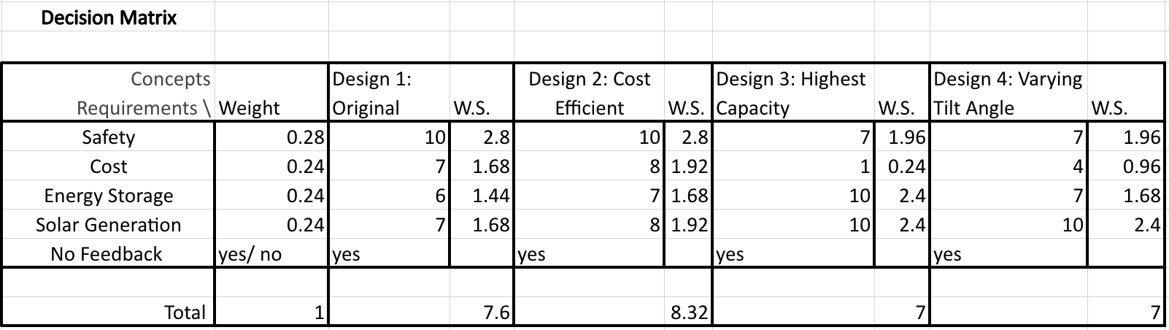
Figure 8: Decision Matrix

5.2. Selected Designs and Justification

The initial stages of concept generation involve using a Pugh chart to compare existing renewable energy designs to a datum, which was selected to be grid supplied power. Each concept was compared to the datum qualitatively, and one choice was selected for further design variations. Because the renewable energy generation system choice is already selected as hybrid solar, this Pugh chart is purely for validation purposes; the Pugh chart concisely compares the desired renewable energy system to other, potentially more effective systems, and solidifies the client’s and team’s choice. The Pugh chart can be viewed in Appendix V.
Based on the overwhelming score on the decision matrix, the recommended design for this project will be Full System Design 2. This design allows the client to accumulate significant renewable power production and storage, while avoiding backfeed into the grid. This design is the most cost effective, as well as having low installation/ maintenance requirements.
The second recommendation is Full System Design 1. This design has been carefully thought out, and will meet all of the necessary engineering requirements. There may be some potential to source discounted options. If this opportunity is presented, this option will be more prioritized.
Scoring criteria for cost, power generation, and battery capacity is based upon back-of-the-envelope calculations for each component. These calculations determine important factors such as cost ratios, kWh of power stored and generated, efficiencies, and total prices. These calculations are displayed in Appendix VI.

6. References
- https://www.energy.gov/eere/buildings/about-building-energy-modeling
- https://www.energy.gov/eere/buildings/articles/energyplus
- https://www.energy.gov/eere/buildings/articles/building-energy-modeling-101-hvac-design-and-operation-use-case
- https://www.energy.gov/eere/buildings/articles/building-energy-modeling-101-inherent-performance-rating-use-case
- https://journals.sagepub.com/doi/10.1177/2399808319841909
- https://www.electricitylocal.com/states/arizona/camp-verde/
- https://www.iea.org/reports/clean-energy-innovation
- https://www.usda.gov/sites/default/files/documents/renewable-energy-trends-2020.p df
- https://palmetto.com/learning-center/blog/everything-you-need-to-know-about-the-solar-tax-credit
- https://azdor.gov/forms/tax-credits-forms/credit-solar-energy-credit
- https://www.solarpanelstore.com/blogs/solar-panel-store-blog/solar-home-grid-tie-system-sizing-part-1-using-a-utility-bill
- https://www.forbes.com/home-improvement/solar/most-efficient-solar-panels
- https://www.forbes.com/home-improvement/solar/what-is-a-solar-battery
- https://www.forbes.com/home-improvement/solar/ground-mounted-solar-panels
- https://www.solar.com/learn/micro-inverter-string-inverter-comparison-solar-equipment
- https://www.solar-electric.com/learning-center/what-components-typically-used-off-grid-solar-power-system/
- https://unboundsolar.com/blog/best-solar-panel-mounts
- https://s3.amazonaws.com/zcom-media/sites/a0i0h00000KyCXiAAN/media/mediamanager/OutBack_Radian_4048A_8048A_Inverter_manual.pdf

- https://www.outbackpower.com/downloads/documents/appnotes/gridzero_app_note.pdf
- https://www.solarreviews.com/blog/what-are-solar-inverters

7. Appendices

Appendix I: Original System Spec Sheets
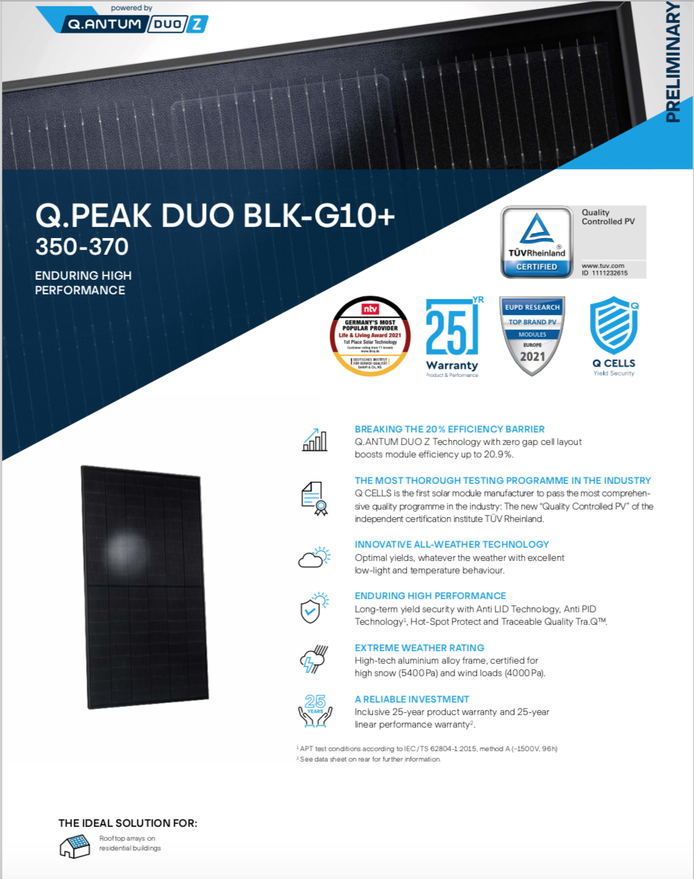

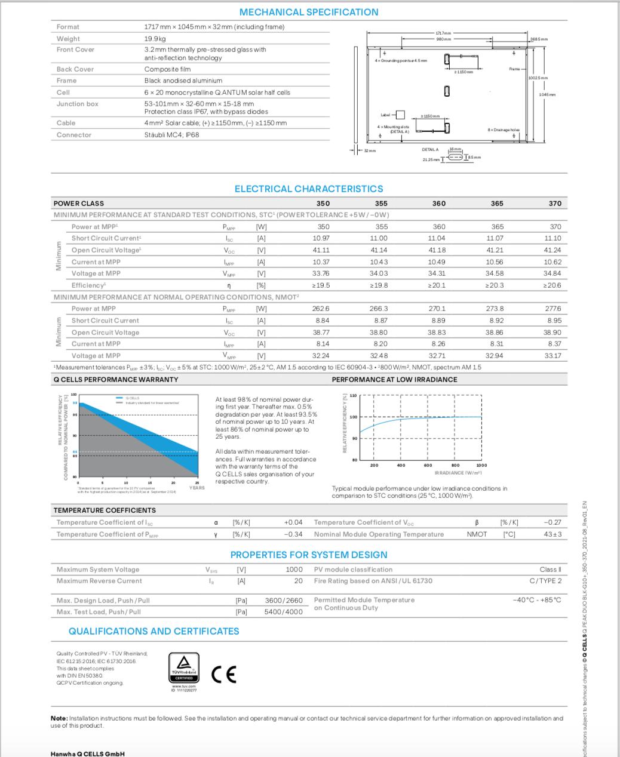

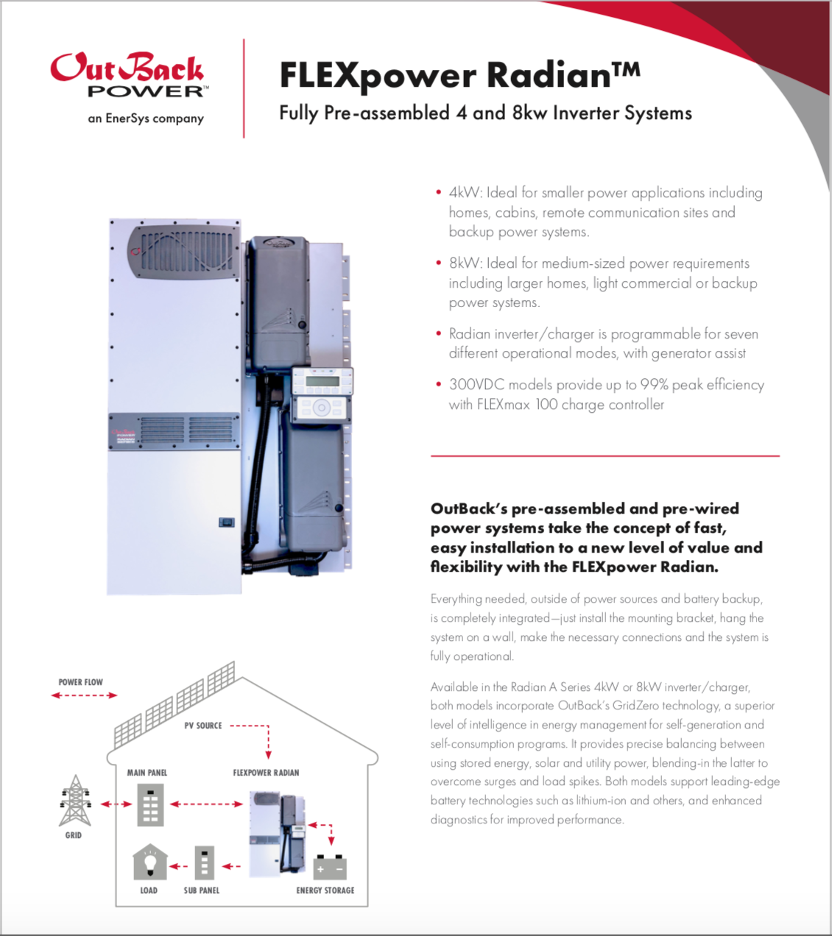

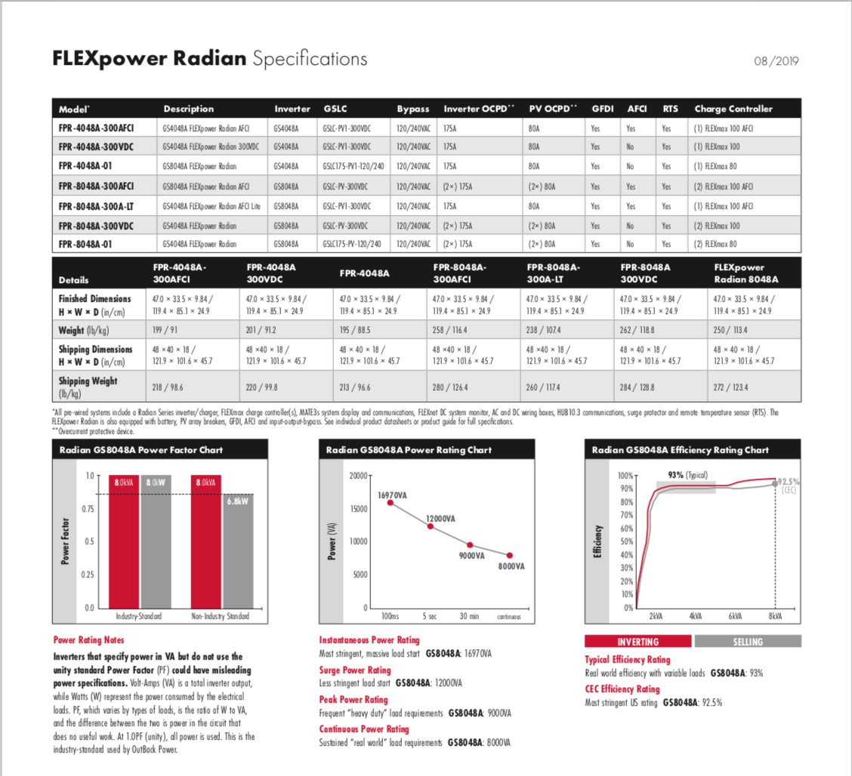

Appendix II: Original Bill of Materials
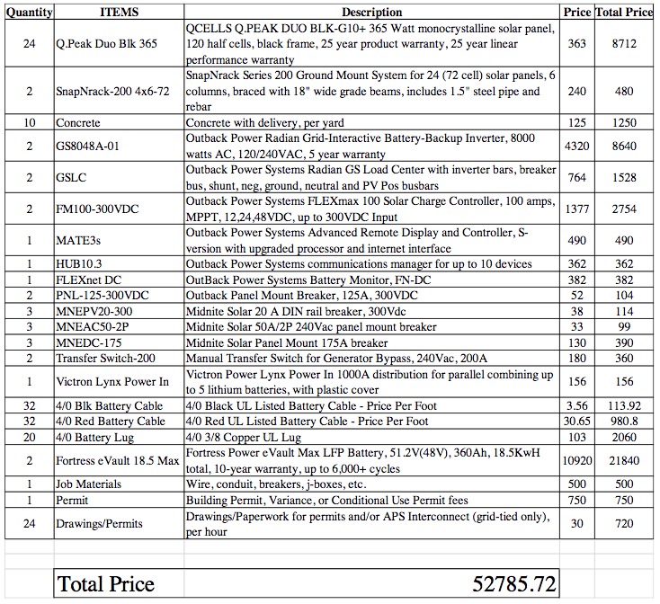

Appendix III: Original System PVWatts Report

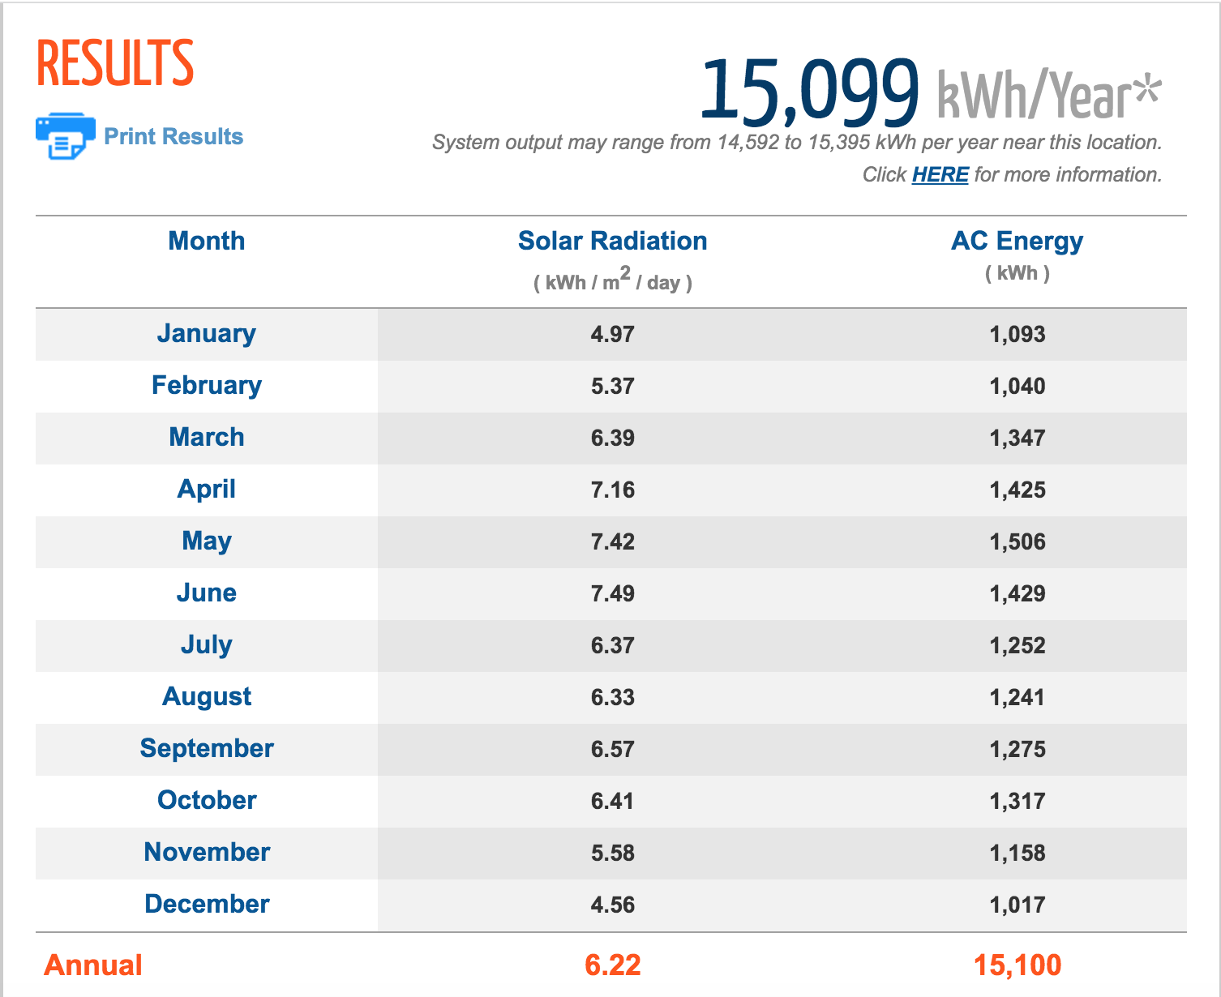

Appendix IV: Original System Quotes
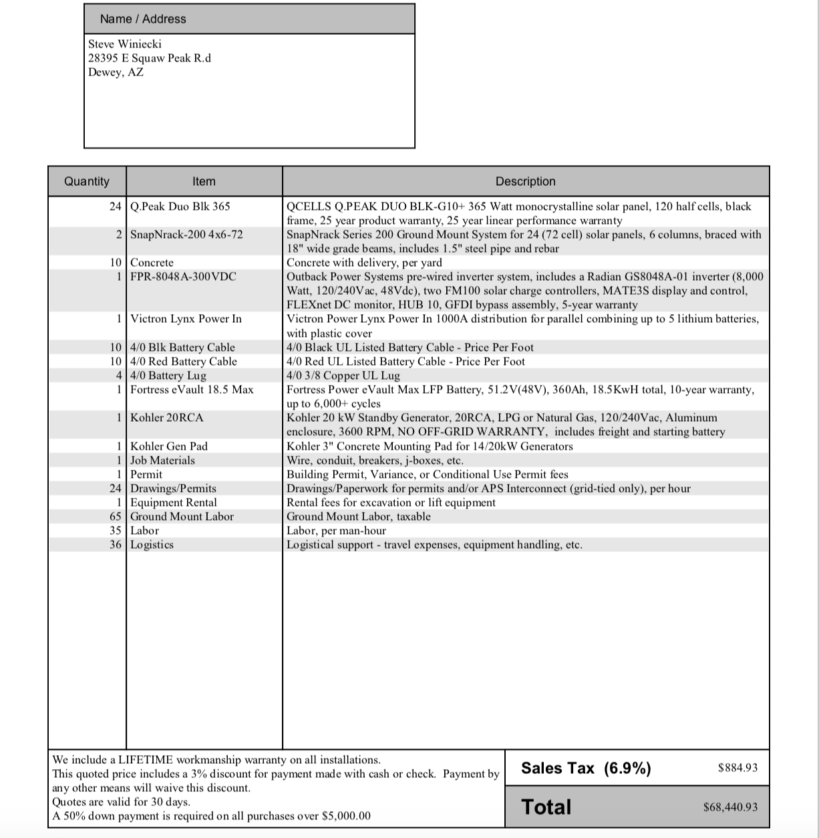
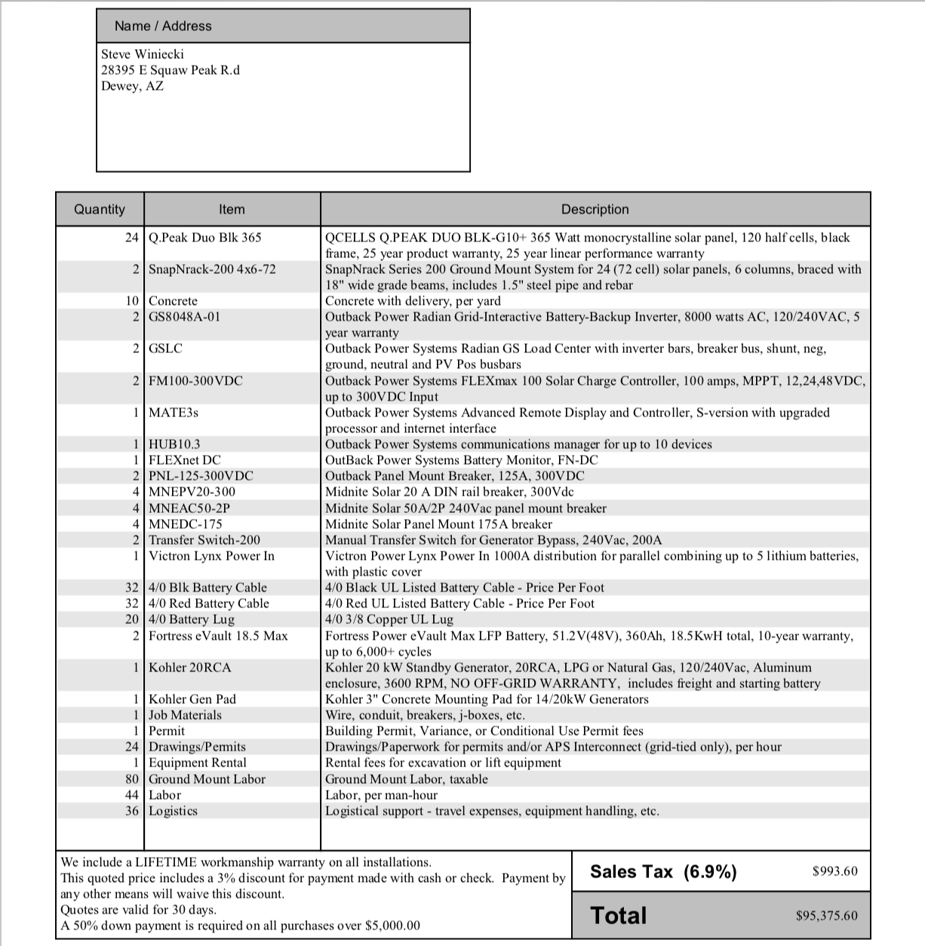

Appendix V: Renewable Energy Systems Pugh Chart

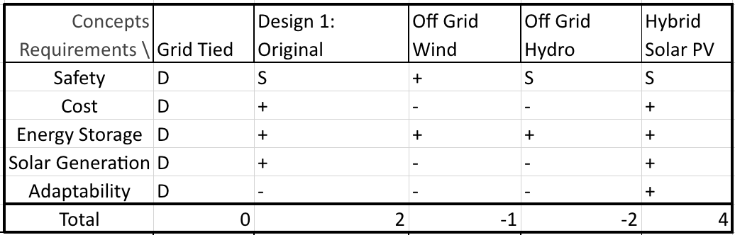

Appendix VI: Back-of-the-Envelope Calculations

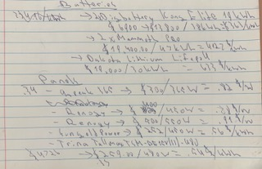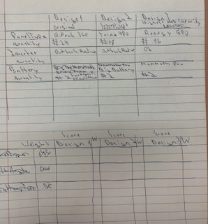

Appendix VII: Black Box Model

Appendix VIII: Work Process Chain Diagram
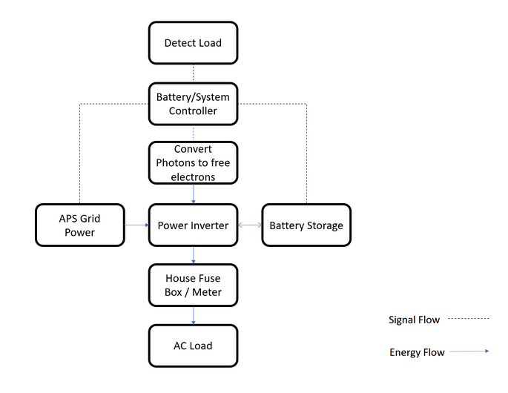

Appendix IX: House of Quality
